April 05, 2010 Via email only: Juliana.Chen@klgates.com

K&L Gates LLP
1717 Main Street, Suite 2800
Dallas, Texas 75201
Attention: Ms. Juliana W. Chen-Associate

Re: New Trademark Application – Grant Notification
Your Ref.:
Our Ref.: K1130-8HNT
Country: Vietnam
Trademark: KOSS and design
Owner’s Name: Koss Corporation
Int’l Class: 09

Dear Ms. Chen,

We are pleased to inform you that we have received Notification No. 15791/SHTT-NH1 dated March 31, 2010 from the National Office of Intellectual Property of Vietnam (NOIP).

As indicated in the Notification, the substantive examination of the above identified trademark application has been successfully completed and the NOIP will issue a certificate of registration for this trademark provided that the fees indicated therein are paid within one month from the date of the Notification, i.e. by April 30, 2010. Failure to pay the fees within the time limit will result in refusal of protection of this trademark in Vietnam. Please confirm that you would like us to pay the fees in accordance with the Notification.

Kindly confirm receipt of this letter by return email and let us have your instructions in this regard before the deadline of April 30, 2010.

We look forward to hearing from you.

Very truly yours,
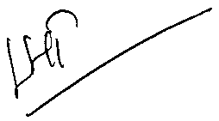
Le Thi Hong Tuyen, Trademark Executive

Copy: Nguyen Thi Phi Nga, Department Head – Intellectual Property

